# Migration in the lens of sustainable adaptation: a tale of two slums in Bangladesh

# 

**Abstract:** The number of global migrants and refugees, including climate migrants, is a subject of controversy. However, there is a consensus that the number of people forced to leave their homes owing to the effects of climate change will significantly rise in the near future. The issue of climate migration necessitates consideration. Nevertheless, there has been no effort to categorize a specific portion of the slum population as climate migrants, despite the fact that climate and non-climate drivers have been recognized in literature. The objective of this study is to determine the percentage of climate-induced migrants residing in two specific slums in Rajshahi, which is the third most populous city in Bangladesh and is particularly susceptible to drought. A comprehensive enumeration took place. According to the survey, nearly 50% of households are classified as climate migrants, predominantly residing with their family. Only a small number of individuals migrated independently to the slum. The primary way of survival is through begging and collecting scrap. The origin of climate migrants is the northern districts of Nilphamari and Gaibandha. The access of basic necessities is inadequate. Labeling slum dwellers as climate migrants does not provide them with any further advantages. Subsequent investigations should prioritize examining the impact of urban governance on promoting a healthy lifestyle for individuals and households who have migrated due to climate-related factors.

**Keywords:** Migration, climate driver, non-climate driver, urban slum, Rajshahi, Bangladesh

**1. Introduction**

Various estimates of the number of refugees range widely, from 150 million to more than a billion, and are debatable in terms of their calculation, accuracy, and cause (Bose, 2016). Yet, it is expected that in the upcoming years, climate change particularly will result in widespread population displacement (Pachauri et al., 2014). According to several estimates made decades back, there would be 200 million environmental refugees worldwide by 2050 (Myers, 1993; IOM, 2008; Johnson, 2009). Forced relocation may go up to 250 million people globally (Yonetani, 2014). A recent estimation forecasts that by 2050 around 143 million people from the global developing South are likely to be subject to forced displacement within the country as a result of climate change (Rigaud et al., 2018). In Bangladesh, it was estimated that around three to ten million people would move from the north to the east of the country (Rana and Ilina, 2021; Hassani-Mahmooei and Parris, 2012).

In 2020, the urban population of Bangladesh exceeded 64 million (World Bank, 2021). The impoverished rural populations are already flocking to urban centers for economic opportunities; the effect of climate change is the added one. Accordingly, sustainability of slum dwellers has attracted many researchers in Bangladesh (Uddin, 2018). Numerous research has concentrated on issues ranging from hosting attitudes towards climate-induced migrants to the impact of climate-induced migration on society, justice, and human rights (Castellano et al., 2021; Ahsan, 2019; Kolstad et al., 2019; Naser et al., 2019). The health condition among climate migrants living in the slums have also attracted many researchers (For example, Koly et al., 2022; Rahaman et al., 2018). Migration due to sea level rise, flood and riverbank erosion, the search for livelihoods, and economic prosperity have also been extensively studied (Davis et al., 2018; Stojanov et al., 2016). The repeated echolalia about the challenges cities face due to migration does not reduce the flow of migrants, while the research about drivers of climate migration and separating climate migrants from the non-climate migrants are understudied, particularly in Bangladesh.

If the drivers are known for individual migrants, climate migrants, for which politically agreed definition is absent yet, can be easily identified. In 2010, the Cancun Agreement, a legal binding to the parties of the United Nations Framework Convention on Climate Change (UNFCCC), identified three categories of climate-indued mobility: displacement, migration and planned relocation. Many years later, the working definition of climate migration, pending legal status, has been formed as "the movement of an individual or groups of individuals who are required to leave their habitual place of residence, or choose to do so, either temporarily or permanently, within a State or across an international border, primarily due to sudden or progressive change in the environment due to climate change" (IOM, 2019). The Intergovernmental Panel on Climate Change (IPCC) marked climate change as one of greatest reasons for mass displacement. This displacement will result in mass migration as an adaptation strategy to already over-crowded cities, creating slums and informal settlements (Castellano et al., 2021; Giti et al. 2021; Rana and Ilina, 2021; Naser et al., 2019; Chen and Mueller, 2018; Pandey et al., 2018; Martin et al., 2013; Afsana and Wahid, 2013).

Not all adaptation measures are sustainable, and popular adaptation does not necessarily guarantee sustainable adaptation. In order to determine if an adaptation intervention is sustainable or not, it is necessary to measure a specific set of indicators. Sustainable adaptation refers to a series of measures that support the achievement of socially and environmentally sustainable development paths, encompassing principles of social justice and environmental integrity (Eriksen et al., 2011).

Research in the recent years focusing on climate and/or environmental migration dealt mostly with the reasons for migration, as well as cause and effect of climate change and migration, and vice versa (Qing et al., 2023; Rahman et al., 2020). Drivers of migration, instead of reasons and factors, along with urbanization and migration nexus, have also received substantial emphasis (Castellano et al., 2021; Eversten and Geest, 2019). A varied degree of anomaly is observed in categorizing the migrant population as climate migrants. Besides, migration in the lens of sustainable adaptation has hardly been investigated. Hence, this research aims to assess internal migration in Bangladesh, based on investigation of two slums in the northwestern district of Rajshahi, in the lens of sustainable adaptation.

This research makes a multifaceted contribution to the existing literature. In contrast to the simple classification of climate-induced migrants by Adri and Simon (2017), this study has comprehensively considered both climate and non-climate factors as drivers of migration from a climate change viewpoint, taking into account objective classification from sources such as Brown (2008) and Rahman et al. (2022). Furthermore, prior studies examining slum populations have seldom conducted a comprehensive enumeration, regardless of the impact of climate change on their displacement. In contrast, this research has successfully surveyed every household in two distinct slums. This research has also evaluated the post-displacement conditions of the households to assess if migration were a sustainable adaptation. Although the slums of Dhaka are extensively examined by most scholars, the slums of Rajshahi, the third largest city with a population above one million, have not received adequate attention in terms of climate migration research. The other sections of the paper are organized as follows: Section 2 discusses migration and sustainable adaptation followed by the methodology in section 3. Section 4 focuses on the results and discussions. Section 5 concludes the article.

**2. Climate change, migration, and sustainable adaptation**

Climate-induced migrants are distinct from other categories of migrants and are also not acknowledged in certain academic debates (Adri and Simon, 2017). Castellano et al. (2021) termed "climate migrant" problematic because it may place greater emphasis on the attraction of the destination rather than the factors that compel people to leave their origin and migrate. The authors also doubted that the use of the term “climate migrant” may reduce the implicit accountability of the global community. Referring to the Foresight Report (2011), Eversten and Geest (2019) have mentioned that the environment can act as both a catalyst and a factor that strengthens the impact of other migration forces.

Schwerdtle et al. (2021) argued that climate migration is neither different from other types of migration nor inherently unique. Migration is driven by diverse causes that differ between countries and even within a country (Ishtiaque and Ullah, 2013). Migration decision is complicated and is influenced by multiple causes, hence it is quite challenging for to comprehend why some individuals intentionally choose to live in the climate vulnerable location or one in slum in a metropolis (Lein, 2010). People may want to leave origin due to negative social and physical conditions, attraction to noneconomic factors in the destination, and nonmaterial causes like strong belief on faith. Hence, economic explanation of migration solely is problematic (Ruback et al., 2004).

There are two assumptions considering the correlation between the environment and internal migration. First, the increased population density, inequitable land distribution, limited job prospects, and poverty compel impoverished individuals to migrate to places those are already vulnerable including to climate hazards, and second, hazards and disasters significantly contribute to the proliferation of informal settlements in metropolitan areas (Lein, 2000). In Bangladesh, individuals predominantly relocate to urban areas due to economic incentives, disparities in income, employment opportunities as well as in response to catastrophic calamities (Nabi, 1992; Mahbub, 1988).

Both climate and non-climate drivers are identified in literature (Brown, 2008). Castelli (2018) classified the drivers into three overarching perspectives: macro, meso, and micro. The environmental condition was addressed within the context of macro drivers, whilst communication technology, education, and marital status were considered within the framework of meso and micro drivers for instance. Black et al. (2011) and Van Hear et al. (2020, 2012) identified that exposure to hazard and environmental change are factors that contribute to the occurrence of certain events including migration. Van Hear et al. (2020, 2012) proposed that environmental disasters serve as a triggering factor. Black et al. (2011) have also recognized quick onset extreme environmental events, such as flood, tsunami, landslide, earthquake, wildfire, volcanic eruption, droughts, and land degradation, as the climate drivers.) Climate variables, such as temperature, weather-related disasters, salinity, coastal erosion, and sea-level rise, have also been argued as the factors driving climate migration (Moor and Wesselbaum, 2023).

According to Fedele et al. (2019), migration due to the impact of climate change may can be termed as transformative adaptation, since it is a strategic approach aims to address the underlying causes of vulnerability. Also, adaptation can be classified in several ways based on distinguishing concepts or traits (Smith and Pilifosova, 2003). However, adaptation strategies have the potential to backfire and actually make a situation more vulnerable instead of lowering susceptibility, commonly referred to as maladaptation (IPCC, 2001; Barnett and O'Neill, 2010). The unintended negative consequences that arise from the implementation of a deliberate adaptation policy or program, affecting either the intended recipients or other individuals involved are maladaptation (Juhola et al., 2016). Maladaptation has been observed in multiple geographical areas and industries. Adaptation measures aimed at mitigating the adverse effects of climate change and climate change-induced disasters incorporate sustainability concerns throughout their planning and execution stages.

Eriksen and O'Brien (2007) have contended that sustainable adaptation should prioritize three fundamental requirements. The first priority is to reduce risks while ensuring the current state of well-being. The second priority is to enhance the ability of disadvantaged groups to adapt. The third priority is to tackle the root causes of vulnerability among the impoverished. Furthermore, it is imperative to verify that prioritizing any of the three relationships does not have a detrimental impact on the other or on both. Adaptation must extend beyond making existing development plans resilient to climate change, and the process of making them resilient must be integrated into broader frameworks for managing climate risks (Brooks et al., 2011).

To achieve sustainable adaptation, it is necessary to expand the scope of existing approaches and focus specifically on vulnerability, resilience, and poverty reduction (Eriksen and Brown, 2011). The concept of sustainable adaptation, which involves implementing interventions that effectively tackle climate change, poverty, and development simultaneously, has been a subject of debate in the past decade. This is especially relevant for developing countries as they grapple with determining the most effective approach to address climate change (Brown, 2011). The use of sustainable adaptation measures decreases susceptibility and improves long-term capacity to withstand and recover from the impacts of climate change (O'Brien and Leichenko, 2007). Barrera et al. (2017) have suggested that post-implementation adaptation interventions should focus on enhancing program quality to maintain sustainability, taking into account the needs of both the institution and the community. Nevertheless, there is a dearth of empirical information about the sustainability of different adaptation initiatives including migration.

### **3. Methodology**

This study utilized a semi-structured questionnaire to collect data. Along with basic demographic information, the questions covered in the survey included climate and non-climate drivers of migration. Climate drivers were categorized as climate process and climate events (Brown, 2008). Climate processes include drought, flood, food insecurity, river erosion, salinity, and sea-level rise. Climate events include sudden extreme climatic events like monsoon flood, storm, hurricane, and tornado. Since Bangladesh is prone to flood, and flash flood is prevalent mostly in the northeastern and southern part of Bangladesh, monsoon flood has been considered as climate process instead of climate event. Non-climate drivers included a lack of preparation for natural disasters and the inability to adapt. Besides the basic demographic queries, information about housing, livelihood condition, access to water and electricity, and the quality of sanitation were also investigated.

**3.1 Study location**

Purposefully, two slums were chosen since these slums comply with the six features of the slum as identified by the Bangladesh Bureau of Statistics (BBS) (2015): structure, density, land ownership, water supply and sanitation, lighting and road facilities, and socio-economic condition. Two slums of the Vodra area, Lakeside Basti (slum) in Ward 19 and Rail Line Basti (slum) in Ward 26 and 27, were investigated. Figure 1 shows the location of the study area.

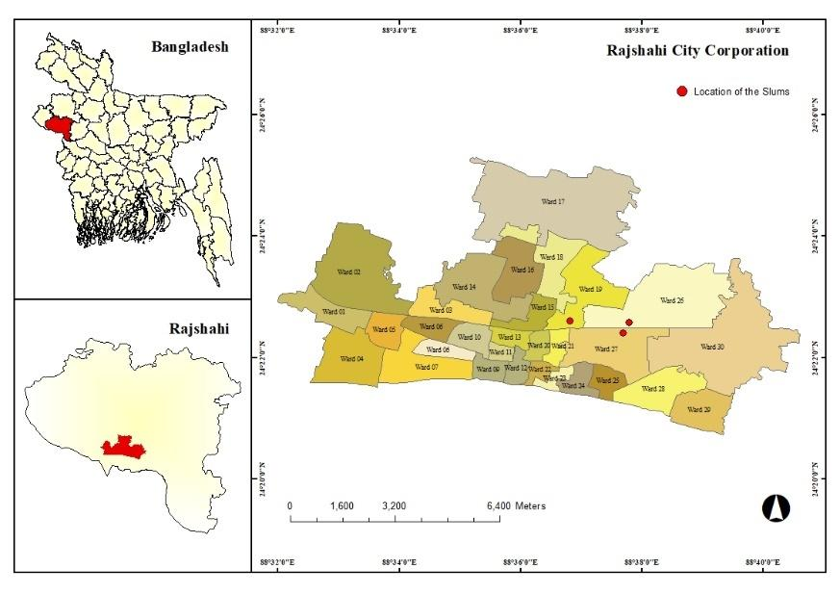

**Figure 1: Location map of the slum areas**

**3.2 Source of data and sample size**

After the purposeful selection of two slums, a complete enumeration took place and a direct data collection method was applied. A total of 206 households, 128 from Vodra Lakeside *basti* (slum) and 78 from Vodra Rail Line *basti*, were surveyed. The respondents were the head of households. After removing the missing data, which was very minimal, a total of 190 interviews were considered for various analyses.

**3.3 Data analysis**

After the basic demographic statistics, both quantitative and qualitative analyses were conducted. Quantitative analyses were executed using Python in Google Colab, employing libraries such as Pandas, Matplotlib, Plotly, and Seaborn. The dataset underwent cleaning using a Python mapping function, followed by one-hot encoding for streamlined analysis. GeoJson-formatted maps visually represented migrants' origins in Bangladesh. The "Migrated From" column underwent cleaning, ensuring only values from Bangladesh districts remained by discarding entries like "India" and "Unknown." Subsequently, climate and non-climate columns were isolated, and their respective values were used to filter the dataset, generating maps based on districts (Figure 2). Furthermore, pie charts were created to visualize the findings as seen in Figure 3,4,6,9. A pie-of-pie chart (Figure 8) showcased the top 5 jobs, isolating others under "Other." The explode parameter enhanced visual separation, and then two connection lines were drawn from the “Other” section to the smaller pie chart for visual acuity. A Pareto chart (Figure 7) illustrated the frequency of families in the same household and their cumulative percentage. Finally, utilizing Pandas and Plotly, a Sankey diagram (Figure 5) was generated by filtering the dataset based on ward and migration reasons, melting the data, aggregating by ward number, and calculating the percentage of migration reasons for each ward. Ward numbers were assigned as sources, variables as targets, and percentages as values.

**4. Results**

**4.1 Migrants' place of origin**

The chosen slums have accommodated a greater number of individuals and families from the Rajshahi and Rangpur divisions. The majority of the populace from the districts of Nilphamari and Rajshahi relocate to the designated slums in Rajshahi. Individuals hailing from Gaibandha, Pabna, and Faridpur have also arrived at the designated slum areas (Figure 2). The occurrence of regional concentration has been identified among the residents of slums. This situation is prevalent in the impoverished areas of Bangladesh. Several slums in Dhaka are designated with names corresponding to the residents' place of origin, such as Bhola basti (Evertsen and Geest, 2019; Schwerdtle et al., 2021). Bhola district is the most expansive island located in the southern region of Bangladesh, in close proximity to the Bay of Bengal. The heatmaps depicting the origins of slum inhabitants exhibit a uniform distribution pattern for both climate-related and non-climate-related factors.



**Figure 2: The source of migrants in specific slums of Rajshahi.**

**4.2 Factors influencing migration**

Individuals residing in the designated slums have relocated as a result of a multitude of causes, primarily stemming from a confluence of diverse forces. Approximately 52% of the indicated reasons can be attributed to the climate factor category, which encompasses both climate events and climate processes (Figure 3). It should be noted that these drivers are not mutually exclusive. The main non-climate factors include absence of alternative sources of income, insufficient access to food, and residing in susceptible areas. The main causes of climate-related issues are primarily associated with drought and salinity, as seen in Figure 4. The Sankey diagram in Figure 5 illustrates the factors that promote movement from two slums across three Wards. The primary factors, namely the absence of sustainable employment opportunities, inadequate access to food, and being situated in a susceptible area, continue to be unchanged.

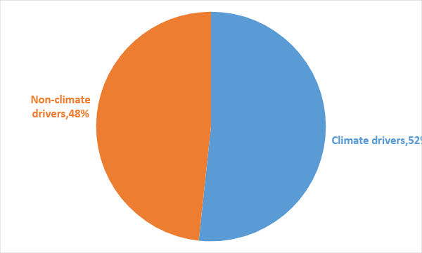

**Figure 3: Climate and non-climate drivers of migration**

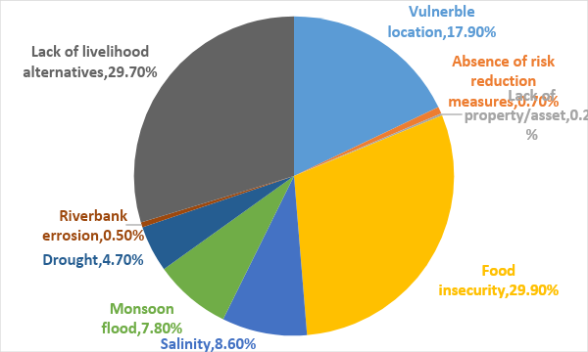

**Figure 4: Drivers of migration**

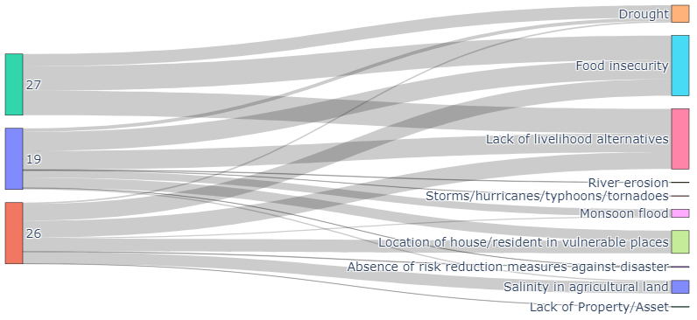

**Figure 5: specific reasons for migration categorized by slum**

**4.3 Demographic characteristics of the residents in the slum**

The majority of individuals living in slums migrated over 20 years ago, with a few exceptions who migrated over 40 years ago. Men head the majority of households, comprising 73% of the total, while women lead the remaining 27%. Approximately 91% of households reside with their family members. Male- and female-headed households living with their respective families exhibit a subtle distinction. Male-headed households have a higher incidence of living with their families compared to female-headed households, as seen in Figure 6.

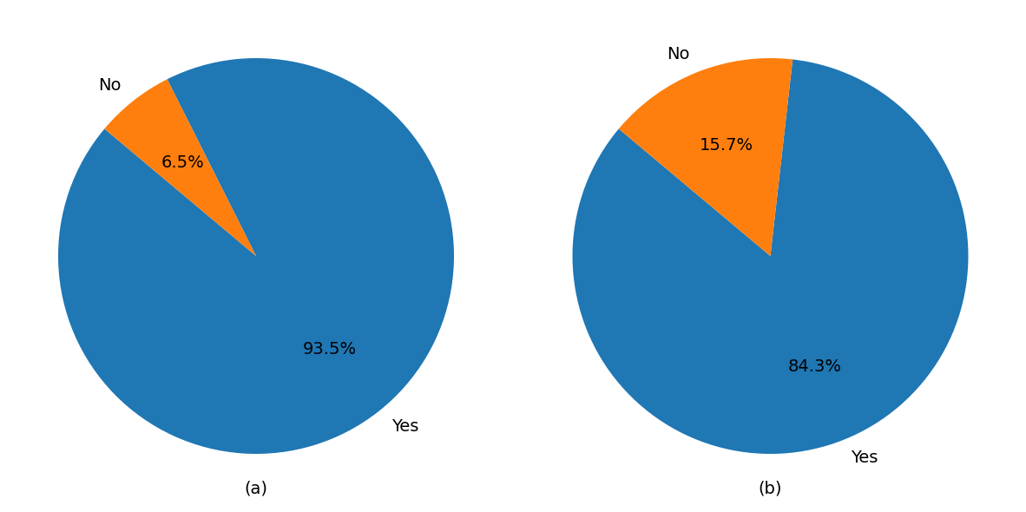

**Figure 6: Accompanying family structure with a male-headed household (a) and a female-headed household (b)**

Multiple families cohabiting in the same house is a widespread occurrence in the slums of Bangladesh. The slums in Rajshahi are indistinguishable. Approximately 85% of families cohabit with many other families in the same residence. Between two and six families cohabitate in the designated slums (Figure 7).

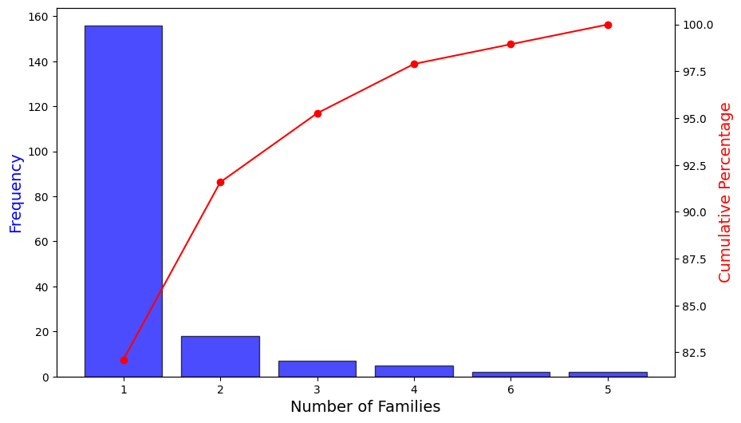

**Figure 7: Presence of families living together in the slums of Rajshahi**

**4.4 Assessment of livelihood condition**

The most commonly practiced professions were begging and scrap gathering. Additional prominent options for earning a living were manual rickshaw pulling, small-scale entrepreneurship, and temporary day laborer positions (Figure 8).

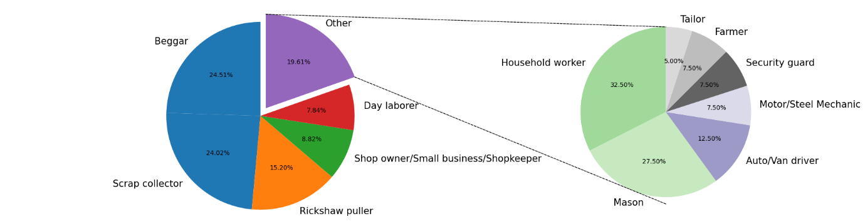

**Figure 8: Primary livelihood options for residents of slums**

The living conditions of displaced migrants are quite arduous. The majority of individuals heavily depend on tube wells for their drinking water and domestic needs. There is also some dependence on water supplied by the city corporation, as shown in Figure 9. A minority of locals also utilize the adjacent lake water, which is deemed unsafe and unhygienic. Female members, regardless of their status in the family, primarily bear the burden of collecting drinking water for almost 90% of homes. Communal bathing or bathing in the lake might be difficult in cold weather. In addition, the slum dwellers have expressed concerns regarding safety and privacy in relation to restroom facilities.

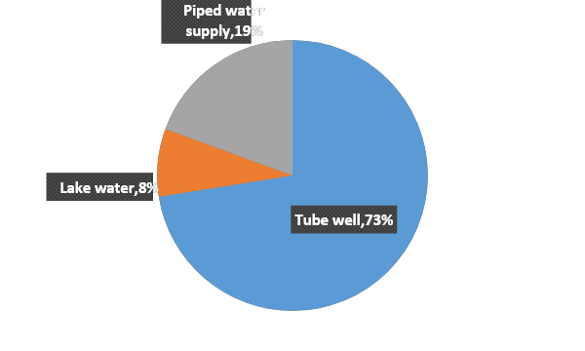

**Figure 9: Access to water**

The neighborhood is facing a substantial health risk due to the prevalence of open dumping in sanitation facilities. The inhabitants have highlighted overcrowding, distance, and blocked latrines as the primary issues. There has been an observed lack of access to electricity and illumination. The major methods of power utilization include batteries, solar power, and lighting.

**5. Discussion**

The decision to relocate or migrate is often influenced by a complex interplay of factors, both environmental and non-environmental. Hence, it is difficult to separate these drivers because they can be deeply intertwined. The case of the two slums of Rajshahi has also shown the same. Hence, this may be argued that a deeper look is essential for climate-induced migration research. Survey-based research is not enough to identify the climate migrants.

While these drivers can be distinct, they often intersect and exacerbate each other. For instance, climate change-induced environmental stressors can lead to economic downturns, food insecurity, and social tensions, which, combined with existing political instability, can further prompt migration.

Understanding migration as a multifaceted phenomenon that's influenced by a complex web of factors—where environmental changes intersect with social, economic, and political dynamics—helps policymakers and communities develop more effective responses to address the needs of migrants and the challenges they face.

Since earlier research argued that younger unmarried women migrate independently more (Eversten and Greet, 2019), the number of households headed by female and living with families as found in the slums of Rajshahi seems well-synced.

However, living in city slums does not necessarily provide better pay, as discovered by Uddin (2018). While migration can provide income-generating activities, livelihood options may be insignificant or inadequate, with financial hardship continuing to hinder children from attending school. Sanitation and access to safe drinking water also remain a concern, particularly for women and girls. The ongoing COVID-19 pandemic has made life even more challenging for climate migrants, and conflicts are not uncommon in slums.

However, as suggested by Giti et al. (2021), livelihood diversification, improved infrastructure, health facilities, social capital, and support from the local government can facilitate better adaptation for migrants in slums. However, policy development to facilitate the adaptive capacity of migration has been a chronic problem (Martin et al., 2013; Ahsan, 2019). To address the challenges faced by climate migrants, policies must be developed to improve their adaptive capacity. National policy documents and implementation plans need to link climate change, migration, and inclusive development, rather than merely accommodating migrants in urban slums. Strategies that address slum socio-ecology and the capacity of slum dwellers can help reduce the challenges faced by climate migrants. Policymakers should take measures, such as registering slum dwellers in a central database, to ensure access to education and health services and improve living standards (Ahsan, 2019; Park, 1928; Pandey et al., 2018)

**5. Conclusion**

Researchers around the world have shown great interest in both internal and international migration due to climate change in large cities. However, there is limited research on smaller cities. This study focused on climate-induced migration in Rajshahi city, a northwest drought-prone area in Bangladesh. The study involved surveying 50 residents living in two slums using a semi-structured questionnaire. The study discovered that individuals from the northern region preferred to migrate with their families, and the primary reasons for migration were riverbank erosion and food insecurity. Although they migrated with hopes of a better life, the post-displacement standard of living was disappointing due to poor infrastructure, lack of sanitation, and limited work and education opportunities. To ensure the sustainable living of climate migrants in urban settlements and slums, innovative and inclusive policies are suggested.

**References**

Afsana, K., Wahid, S.S., 2013. Health care for poor people in the urban slums of Bangladesh. Lancet, 382(9910), 2049-2051.

Ahsan, R., 2019. Climate-induced migration: impacts on social structures and justice in Bangladesh. South Asia Res. 39(2), 184-201.

Ahsan, R., Karuppannan, S., Kellett, J., 2011. Climate migration and urban planning system: a study of Bangladesh. Environ. Justice. 4(3), 163-170.

Alam, M.Z., Rahman, M.A., Al Firoz, M.A., 2013. Water supply and sanitation facilities in urban slums: a case study of Rajshahi city corporation slums. Am J of Civil Eng. Arc. 1(1), 1-6.

Angeles, G., Lance, P., Barden-O'Fallon, J., Islam, N., Mahbub, A. Q. M., & Nazem, N. I. (2009). The 2005 census and mapping of slums in Bangladesh: design, select results and application. International journal of health geographics, 8(1), 1-19.

BBS, 2015. Preliminary Report on Census of Slum Areas and Floating Population 2014, Bangladesh Bureau of Statistics, Statistics and Informatics Division, Ministry of Planning. Retrieved from chrome-http://203.112.218.65:8008/WebTestApplication/userfiles/Image/Slum/Preli_Slum_Census.pdf (accessed 12 November 2023).

Brown, O., 2008. Migration and climate change. In: IOM Migration Research Series. International Organization for Migration. Geneva, Switzerland.

Castles, S., 2013. The forces driving global migration. J. Intercult. Stud. 34(2), 122-140.

Castellano, R., Dolšak, N., Prakash, A., 2021. Willingness to help climate migrants: a survey experiment in the Korail slum of Dhaka, Bangladesh. PloS One, 16(4), p.e0249315.

Chen, J., Mueller, V., 2018. Coastal climate change, soil salinity and human migration in Bangladesh. Nat Clim Chang. 8(11), 981-985.

Davis, K.F., Bhattachan, A., D’Odorico, P., Suweis, S., 2018. A universal model for predicting human migration under climate change: examining future sea level rise in Bangladesh. Environ. Res. Lett. 13(6), p.064030.

Giri, M., Bista, G., Singh, P.K., Pandey, R., 2021. Climate change vulnerability assessment of urban informal settlers in Nepal, a least developed country, J. Clean. Prod. 307, p.127213.

Hassani-Mahmooei, B., Parris, B.W., 2012. Climate change and internal migration patterns in Bangladesh: an agent-based model. Environ Dev Econ. 17(6), 763-780.

Hossain, M.S., 2021. Exploring the architectural dimensions of vulnerability: a case of the participatory upgradation in informal settlement at Talaimari, Rajshahi. J. Eng. Sci. 12(2), 29-46.

IOM. 2014. Migration, environment and climate change: evidence for policy: Glossary. International Organization for Migration, Geneva, Switzerland

IOM. 2019. Glossary on Migration. International Migration Law, International Organization for Migration, Geneva, Switzerland. Retrieved from <https://environmentalmigration.iom.int/sites/g/files/tmzbdl1411/files/iml_34_glossary.pdf> (Accessed 12 December 2023)

IPCC. 2007. Fourth Assessment Report: Climate Change 2007. Working Group II: impacts, adaptation and vulnerability. Geneva, Switzerland.

Johnson, L.S., 2009. Environment, security and environmental refugees. J. Animal & Envtl. L., 1, 222.

Kaczan, D.J., Orgill-Meyer, J., 2020. The impact of climate change on migration: a synthesis of recent empirical insights. *Clim Change.* *158*(3), 281-300.

Kolstad, I., Bezu, S., Lujala, P., Mahmud, M. and Wiig, A., 2019. *Does changing the narrative improve host community attitudes to climate migrants? Experimental evidence from Bangladesh* (No. 3). CMI (Chr. Michelsen Institute), Bergen, Norway.

Laczko, F., Piguet, E., 2014. Regional perspectives on migration, the environment and climate change. In *People on the Move in a Changing Climate* (pp. 1-20). Springer, Dordrecht.

Al Mamun, M., Rahman, S.M., Uddin, M., Sultan-Ul-Islam, M., Khairul, A.M., Rahman, S.M., 2021. Rainfall and drought tendencies in Rajshahi division, Bangladesh. *Geogr. Environ. Sustain.* *14*(1), 209-218.

Martin, M., Kang, Y.H., Billah, M., Siddiqui, T., Black, R., Kniveton, D., 2013. Policy analysis: Climate change and migration Bangladesh. *Dhaka, Bangladesh: Refugee and Migratory Movements Research Unit (RMMRU)*.

Myers, N., 1993. Environmental refugees in a globally warmed world. *Bioscience*, *43*(11), 752-761.

Naser, M.M., Swapan, M.S.H., Ahsan, R., Afroz, T., Ahmed, S., 2019. Climate change, migration and human rights in Bangladesh: perspectives on governance. *Asia Pac Viewp.* *60*(2),175-190.

Park, R.E., 1928. Human migration and the marginal man. *Am. J. Sociol.* *33*(6), 881-893.

Pandey, R., Alatalo, J.M., Thapliyal, K., Chauhan, S., Archie, K.M., Gupta, A.K., Jha, S.K., Kumar, M., 2018. Climate change vulnerability in urban slum communities: investigating household adaptation and decision-making capacity in the Indian Himalaya. *Ecol. Indic*, *90*, 379-391.

Qing, H., Kumar, R., & Kumar, A. (2023). Climate change and human migration: Perspectives for environmentally sustainable societies. Journal of Geochemical Exploration, 107352.

Rahaman, M.A., Rahman, M.M., Bahauddin, K.M., Khan, S., Hassan, S., 2018. Health disorder of climate migrants in Khulna City: an urban slum perspective. *Int Migr.* *56*(5), 42-55.

Rana, M.M.P., Ilina, I.N., 2021. Climate change and migration impacts on cities: lessons from Bangladesh. *Environ Challen.* *5*, 100242.

Reuveny, R., 2007. Climate change-induced migration and violent conflict. *Polit Geogr,* *26*(6), 656-673.

Sahu, S.K., Beig, G., Parkhi, N., 2015. High resolution emission inventory of NOx and CO for mega city Delhi, India. *Aerosol Air Qual. Res.*, *15*(3), 1137-1144.

Smith JA, Flowers P, Larkin M., 2009, *Interpretative phenomenological analysis: theory, method and research*. SAGE, London: SAGE

Smith, J.A., Osborn, M., 2015. Interpretative phenomenological analysis as a useful methodology for research on the lived experience of pain. Br. J. Pain. *9*(1), 41-42.

Stojanov, R., Kelman, I., Ullah, A.A., Duží, B., Procházka, D., Blahůtová, K.K., 2016. Local expert perceptions of migration as a climate change adaptation in Bangladesh. *Sustainability*, *8*(12), 1223.

Uddin, N., 2018. Assessing urban sustainability of slum settlements in Bangladesh: Evidence from Chittagong city. J Urban Manag. 7(1), 32-42.

URBAN LEDS. 2020. GHG emissions baselines established in model cities of Narayanganj and Rajshahi with Urban-LEDS II support. Retrieved from https://urban-leds.org/ghg-emissions-baselines-established-in-model-cities-of-narayanganj-and-rajshahi-with-urban-leds-ii-support/ (Accessed 31 July 2021)

World Bank. 2021. Urban population (% of total population)- Bangladesh. World Bank Database. Retrieved from https://data.worldbank.org/indicator/SP.URB.TOTL.IN.ZS?end=2020&locations=BD&start=1960&view=chart (Accessed 19 July 2021)

Castelli, F. (2018). Drivers of migration: why do people move?. Journal of travel medicine, 25(1), tay040.

Carling, J., & Collins, F. (2018). Aspiration, desire and drivers of migration. Journal of Ethnic and Migration Studies, 44(6), 909-926.

Van Hear, N., Bakewell, O., & Long, K. (2012). Drivers of migration. Migrating out of Poverty Research Programme Consortium Working Paper 1 March 2012. Retrieved from https://opendocs.ids.ac.uk/opendocs/bitstream/handle/20.500.12413/14821/wp1-drivers-of-migration.pdf?sequence=1 (Accessed 3 December 2023)

Moore, M., & Wesselbaum, D. (2023). Climatic factors as drivers of migration: a review. Environment, Development and Sustainability, 25(4), 2955-2975.

Van Hear, N., Bakewell, O., & Long, K. (2020). Push-pull plus: reconsidering the drivers of migration. In Aspiration, Desire and the Drivers of Migration (pp. 19-36). Routledge.

Black, R., Adger, W. N., Arnell, N. W., Dercon, S., Geddes, A., & Thomas, D. (2011). The effect of environmental change on human migration. Global environmental change, 21, S3-S11.

Lilleør, H. B., & Van den Broeck, K. (2011). Economic drivers of migration and climate change in LDCs. Global environmental change, 21, S70-S81.

Carling, J., & Talleraas, C. (2016). Root causes and drivers of migration. Oslo: Peace Research Institute Oslo (PRIO), 2016, 1-44.

Herrmann, M & Svarin, D 2009, Environmental pressures and rural-urban migration: The case of Bangladesh, MPRA Paper No. 12879, <http://mpra.ub.uni-muenchen.de/12879/>

Nabi, AKMN 1992, ̒Dynamics of Internal Migration in Bangladesh̕, Canadian Studies in Population, vol. 19, no. 1, pp. 81-98.

Rokib, A & Islam, R 2009, ̒Effect of Some Selected Sociodemographic Variables on Male Migrants on Bangladesh̕, Current Research Journal of Economic Theory, vol. 1, no. 1, pp. 10-14.

Ullah, AKMA 2004, ̒Bright City Lights and Slums of Dhaka City: Determinants of Rural-Urban Migration in Bangladesh̕, Migration Letters, vol. 1, no. 1, pp. 26-41.